Inverse responses of species richness and species niche breadth to human development

**Abstract**

We demonstrate that plant species richness and niche breadth show contrasting relationships with human development, and that both

**Introduction**

Understanding the patterns and processes that maintain species diversity is a central goal of ecology

Classic ecological theory tells us that species can coexist ewhen they inhabit distinct niches

Human development can alter biotic interactions that shape communities which can have repercusions for ecosystem functioning, resilience…

Last paragraph:

In this experiment we use a provincial scale assessment of wetland plant species occurrences to compare the responses of species richness and niche breadth to human development. Specifically, we test the hypothesis that high species richness at intermediate disturbance levels can be explained by niche specialization at high and low disturbance. We predict that communities at intermediate disturbance levels will have high species richness and will be inhabited by generalist species with high niche breadth. We further hypothesize that the introduction of exotic species at high human development will displace natives and contribute to the low richness.

patterns of species richness correspond to changes in niche breadth and the introduction of exotic species

Questions (not included in text, just for our guiding reference):

1. How do patterns of wetland plant species richness vary across a human development gradient?
2. How does niche breadth vary across a human development gradient?
3. To what extent can patterns of (a) species richness and (b) niche breadth be explained by exotic species?

**Results**

There was a peaked, unimodal response of wetland vascular plant species richness across Alberta (marginal-R² = 0.18, conditional-R² = 0.74, all *P* < 0.001; ΔAIC vs linear model = 99.4). Model residuals display no spatial autocorrelation (significant Moran I indices all < 0.15, Supplementary material S1). Species richness was highest between X and Y% human development and lowest at the highest human development levels. We found a significant difference in the composition of wetlands at the lowest (__) and highest (XX) development levels (Figure S1 NMDS with 3 groups; PERMANOVA stats). Undisturbed wetlands were inhabited by (list some species). In contrast, highly disturbed wetlands were inhabited by (list some species); these are largely non-native planted as agricultural crops. The plant composition of wetlands at intermediate disturbance levels overlapped with those of the high and low development wetlands but was compositionally distinct (Figure S1; pairwise permanova stats again?)

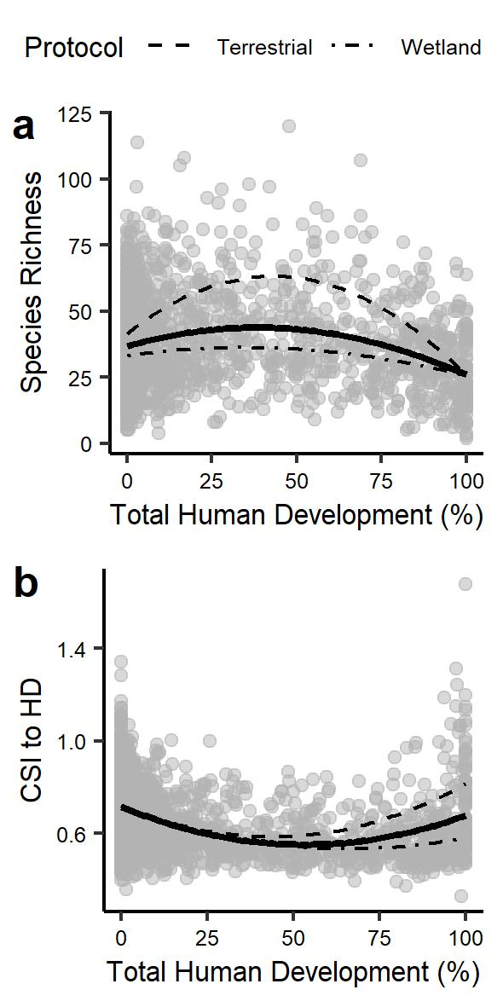

Figure 1: Richness and community specialization in function of human disturbance. (a) Plants species richness in Alberta in function of percent of human disturbance. Solid line represents the mean relationship of the two protocols (wetland and terrestrial) and lighter dashed lines represent the respective protocols from the fitted random effect model (marginal-R² = 0.18, conditional-R² = 0.74, all *P* < 0.001). (b) Community specialization index (CSI) of plants communities in function of percent of human disturbance. Solid line represents the mean relationship of the two protocols (wetland and terrestrial) and lighter dashed lines represent the respective protocols from the fitted random effect model (marginal-R² = 0.15, conditional-R² = 0.82, all *P* < 0.001).

Richness-disturbance relationship

Among the different random effect models compared using AIC, polynomial model including protocol effect explained better the relationship between species richness and human disturbance than the respective simple linear model (ΔAIC = 99.4, marginal-R² = 0.18, conditional-R² = 0.74, all *P* < 0.001). As the quadratic term of the model is significant and positive, the vertex point is a local maximum. Hence, polynomial regressions peak at X% and X% for the wetland and terrestrial protocol respectively. Species richness peaked at intermediate disturbance (Fig. 1a), supporting the intermediate disturbance hypothesis. Model residuals display no spatial autocorrelation (significant Moran I indices all < 0.15, Supplementary material S1).

Figure 1: Richness and community specialization in function of human disturbance. (a) Plants species richness in Alberta in function of percent of human disturbance. Solid line represents the mean relationship of the two protocols (wetland and terrestrial) and lighter dashed lines represent the respective protocols from the fitted random effect model (marginal-R² = 0.18, conditional-R² = 0.74, all *P* < 0.001). (b) Community specialization index (CSI) of plants communities in function of percent of human disturbance. Solid line represents the mean relationship of the two protocols (wetland and terrestrial) and lighter dashed lines represent the respective protocols from the fitted random effect model (marginal-R² = 0.15, conditional-R² = 0.82, all *P* < 0.001). Colored scale referred to the proportion of exotic species in communities.

Community specialization-disturbance relationship

Model selection process selected the polynomial model including protocol effect explaining best the relationship between community specialization and human disturbance (marginal-R² = 0.15, conditional-R² = 0.82, all *P* < 0.001). The quadratic curve explained better the relationship than a simple linear regression (ΔAIC = 26.13). As the quadratic term of the model is significant and negative, the vertex point is a local minimum. Hence, for both protocol, community specialization indices are, on average, maximum at both extremum of the human disturbance gradient (Fig. 1b). Model residuals display no spatial autocorrelation (significant Moran I indices all < 0.05, Supplementary material S1).

Exotic species and species composition shift

Pursued explanation of the pattern of species richness and community specialization along the human disturbance gradient is the difference in proportion of native and exotic species in communities. To test this hypothesis, proportion of exotic species was added as a fixed and interaction effect of human disturbance to the best random effect model exploring the relationship between CSI and human disturbance. The random effect model incorporating the proportion of exotic species displayed a better fit than the random effect polynomial model (ΔAIC = 58.6, marginal-R² = 0.18, conditional-R² = 0.81). Except the quadratic term of human disturbance (*P* = 0.59) and the proportion of exotic species (P = 0.07), all terms of the model were significant (*P* < 0.001). Interaction effect between proportion of exotic species and second order polynomial of human disturbance show that proportion of exotic species increase significantly along the human disturbance gradient (as displayed in Figure 2b). CSI quadratic relationship with human disturbance is hence also explained by the increase in proportion of exotic species.

The previous result should be reflected by a change in species composition of communities along the gradient. Multiple Response Permutation Procedure (MRPP) show that there is a significant difference (*P* < X) in community composition between the least (< X%) and the most (> X%) disturbed part of the gradient. Half of the species the most strongly associated with the most disturbed part of the gradient are exotic species (Figure 2). **MORE**

Figure 2: NMDS (or hierarchical clustering?) displaying groups and differences?

**Discussion**

**Acknowledgement**

**References**

**Supplementary materials**

S1 Models residual spatial autocorrelation analyses using correlog function of package pgirmess.

Figure S1A Correlogram